A picture containing clipart

Description generated with very high confidence

Hands-on

Creating a Function

UNIX/Linux Training

[**support@intellipaat.com**](mailto:support@intellipaat.com)

**+91-7022374614**

**US: 1-800-216-8930(Toll Free)**

**Creating a Function**

**Step 1:** Go to the Lambda console and click the Create function button

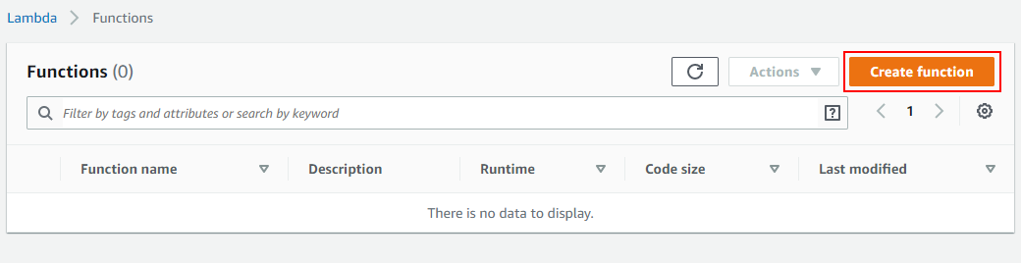

**Step 2:** Go ahead with Author from scratch. Then give your function a name, choose the runtime and go ahead click onCreate Function.

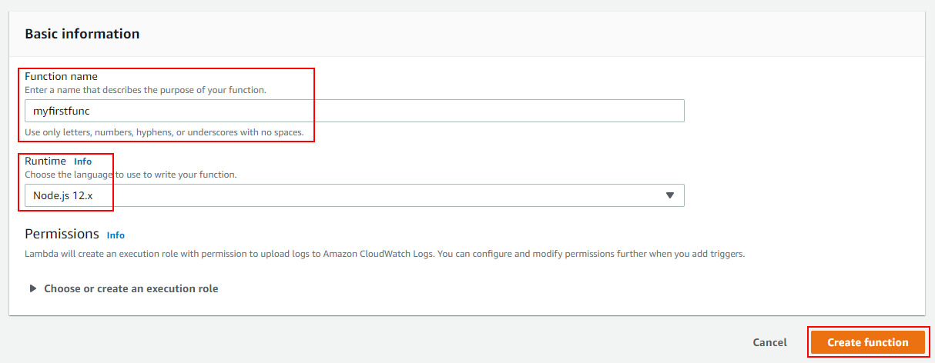

**Step 3:** You have created your function successfully

